NAME: BHAGIRATI PATIL

Email id: bhagyacp@gmail.com

Contact no: 9663483700

Branch: Computer Science and Engineering

College: B.V. Bhoomaraddi College of Engg & Tech.

NAME: CHINMAYI DIXIT

Email id: chinu.2070@gmail.com

Contact no: 9620958379

Branch: Computer Science and Engineering

College: B.V. Bhoomaraddi College of Engg & Tech.

NAME: DEEPIKA B

Email id: deepika.k2010@gmail.com

Contact no: 9739302046

Branch: Computer Science and Engineering

College: B.V. Bhoomaraddi College of Engg & Tech.

NAME: ABHISHEK SINHA

Email id: abhishek.sinha.cool@gmail.com

Contact no: 8867640574

Branch: Computer Science and Engineering

College: B.V. Bhoomaraddi College of Engg & Tech.

**AN ANDROID COMMUNICATOR**

Bhagirati Patil, Chinmayi Dixit

Computer Science & Engineering Department, B.V.Bhoomaraddi College of Engineering and Technology   
Hubli-580030, Karnataka, India.

[bhagyacp@gmail.com](mailto:bhagyacp@gmail.com)

[chinu.2070@gmail.com](mailto:chinu.2070@gmail.com)

**ABSTRACT**

The aim of the project “An Android Communicator” is to create A P2P Communication Framework for Android Mobile Platform.Android mobiles are present everywhere. And people want to share content spontaneously in structured environments such as offices, dining rooms, hotels, conference rooms, cafeteria and wherever it is possible to set up point-to-point communication. Android phones are capable of utilizing Wi-Fi to set up spontaneous communication end-points employingMulticasting.

This project implements a simple and efficient framework using standard multicasting facilities. This project builds P2P applications demonstrating spontaneous group creation and content sharing within structured environments.

Three representative applications include camera preview video streaming, group chatting and files streaming among multiple Android phones.

Basic Study and Programming Tasks: Multicasting basics, Berkley Socket programming and Android networking API.

KEYWORDS:

SRS, P2P, OS, API, SDD, UI

**1 INTRODUCTION**

What is P2P?

In networking, the Point-to-Point

Protocol, or PPP, is a data-link protocol commonly used in establishing a direct connection between two networking nodes.

It can provide connection authentication, transmission encryption privacy, and compression.

PPP Configuration Options:

Authentication - Peer routers exchange authentication message. Two authentication choices are Password Authentication Protocol (PAP) and Challenge Handshake Authentication Protocol (CHAP).

Compression - Increases the effective throughput on PPP connections by reducing the amount of data in the frame that must travel across the link. The protocol decompresses the frame at its destination.

Error detection - Identifies fault conditions.

Multilink - Provides load balancing several interfaces used by PPP through Multilink PPP

Basic knowledge required:

Multicasting:

Multicasting is the ability to transmit a single stream to multiple subscribers at the same time. Unlike conventional streaming, it does not need one stream per recipient. It is the task of the routers to track subscriptions and to create copies only on an as-needed basis. Multicast routing involves two components, the subscribers and the routers. Group Management is the heart of multicasting. Each router keeps track of subscribers to a given stream and forwards the relevant information to the next router out for that stream.

Berkley socket programming:

Berkeley sockets (also known as the BSD socket API) originated with the 4.2BSD Unix operating system (released in 1983) as an API. The Berkeley sockets API comprises a library for developing applications in the C programming language that perform inter-process communication, most commonly for communications across a computer network. The Berkeley socket interface is an application programming interface (API) to code applications performing communication between hosts or between processes on one computer, using the concept of an Internet socket. It can work with many different Input/output devices, although support for these depends on the operating-system implementation.

Android Networking API:

Network programming plays an important role in wireless application development. Android contains the Apache HttpClient Library and this library is the preferred way of performing network operations in Android. Android also allows accessing the network via the standard Java Networking API (java.net package). Even if java.net package is used it internally uses the Apache library. To access the internet your application requires the "android.permission.INTERNET" Permission Network Related Packages in Android: java.net ,java.io, java.nio, java.nio, org.apache.*, android.net, android.net.http, android.net.wifi etc.

Constraints are:

* For p2p sharing, WI-FI connectivity should be available.
* Android platform is necessary.

**2 PROBLEM DEFINITION**

To build A P2P communication framework for android mobile platform.

A OBJECTIVES

* To create P2P communication for android mobiles.
* Network is setup through only WIFI.
* To implement a simple and efficient framework using standard multicasting facilities.

B ADVANTAGES OF THE SYSTEM

* Sharing of files, images, videos among many phones using WIFI.
* Explore your own files

C SCOPE OF PROJECT

This app will be used on the Android mobile OS, and is primarily intended to allow users to utilize Wi-Fi to set up spontaneous communication end-points employing Multicasting. Some benefits of developing this app for the Android phone include: Content sharing within structured environments like offices, dining rooms, hotels, conference rooms, cafeteria.

* Camera preview Video streaming.
* Files streaming among multiple Android phones

Eg.:.pdf,.png,.wav,.mp3,.3gp,.jpeg,.mp4 FORMATS etc.

* Sending ping messages to all devices in the selected group
* Chatting with groups

D PRODUCT PERSPECTIVE

This product is a new, self-contained product. And it is to build an Android based application that will provide the users with reliable software which creates an efficient and simple communication point to point framework.

E USER CLASSES AND CHARACTERISTICS

* The most important users for our software will be the people in offices, dining rooms, hotels, conference rooms and cafeteria because they will be our primary users that we are targeting.
* Since our software will be available to public in Android market place, and on the company website, anyone with an Android phone can be our potential users.

F OPERATING ENVIRONMENT

Hardware requirements

Device : Android enabled smart phone.

System : Desktop (min 512MB RAM

& 40GB Hard Disk).

Mobile RAM : 279 MB or more.

Modem : WIFI 802.11IEEE Wireless

Ethernet

Software requirements

Operating system: Windows XP and

Android

Software : Android SDK 2.2 or above

IDE : Helios Eclipse version 3.6.1

G ASSUMPTIONS AND DEPENDENCIES

Assumptions:

* All Android phones are able to run our software correctly.
* Installing, Removing and Updating software onto the Android O/S is easily achievable.
* Android provides application needs such as simple implementation into a graphical user interface.
* Android users will have phones using a touch screen and not a keypad.

H DEPENDENCIES

System shall be dependent on a machine running with java plug-in.

**3 SRS**

A FUNCTIONAL REQUIREMENTs

* Initialization and termination Process

Through this process user shall be able to start and establish a group creation for sharing

Functionality:

System should allow user to

* Detect devices connected to the WI-FI.
* Send a request to join a group.
* Create a group with 2 or more devices.
* Save group details for further use.
* Create temporary groups spontaneously.
* Disconnect from group at will.

System should provide Proper authentication for security purpose for different groups.

* Connection process

Through this process user shall be able to request in an already established connection.

System should allow users to

* Select which group to connect to.
* Save group details for further use.
* Display network strength.
* Choose which WIFI network to connect to
* Sharing process

System should allow users to

* Send files to other devices on the groups.
* Mark a file as shared.
* Cancel a transaction in between.
* Send notifications after a file was sent or if there were any errors.
* Provide access if authentication is valid.
* Send ping messages to all devices in the selected group.

A device on the group should be able to access shared files on other devices on the group

* Camera preview video streaming process

System should allow users to

* Chat with the group
* Send live camera video to the selected device.

B NONFUNCTIONAL REQUIREMENTS

Performance requirements

* Performance intensive operations like Detection of devices, sending requests, Creation of groups with available phones during initiation phase will take less than 10 sec 97% of times.

Security Requirements

The following is a list of security requirements that indicate how the system shall protect itself and its sensitive data and communications from accidental, malicious, or unauthorized access, use, modification, or destruction

* The system shall not allow addresses of unauthorized devices to be stored into the system’s repository.
* The system shall not permit unauthorized devices to access or participate in any activity started by the device concerned user.
* The system shall not allow confidential data stored in the system’s database to be accessed, whether directly or indirectly, by client (mobile) users.

**4 SDD**

A COMMON SCENARIO WITH USE CASES DESCRIPTIONS

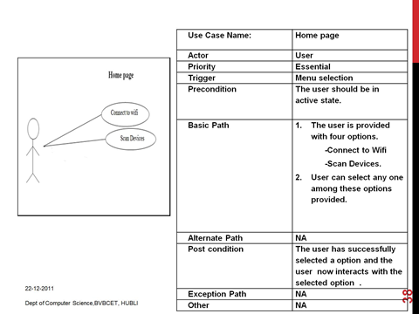

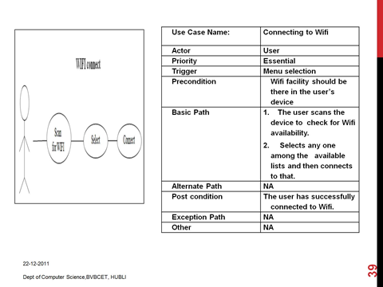

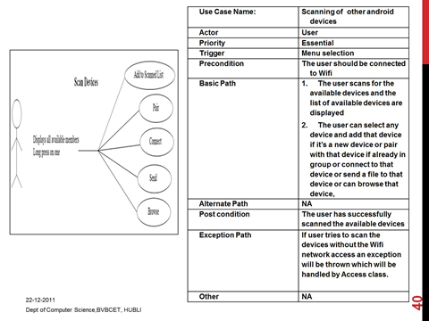

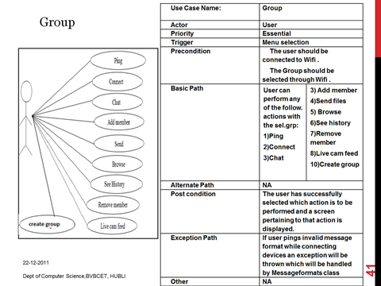

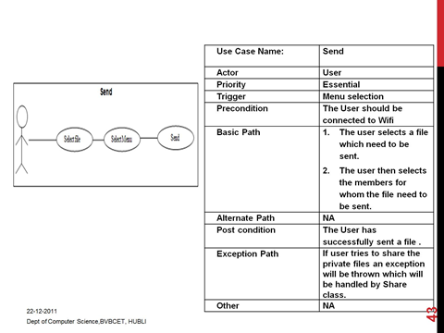

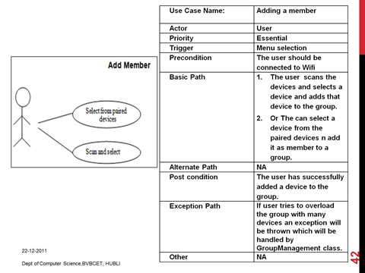

B USER INTERFACES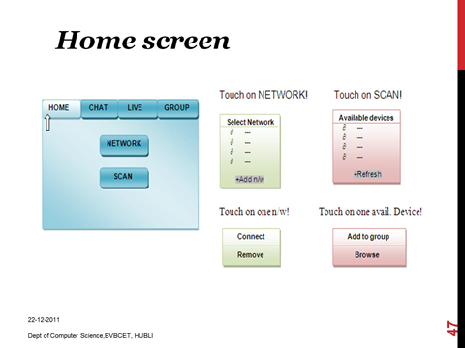

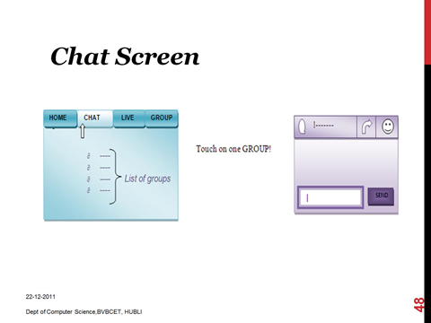

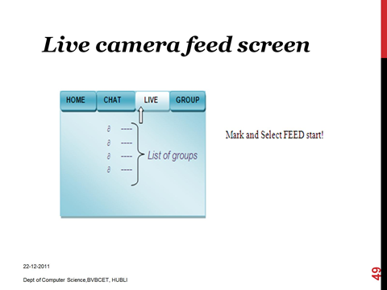



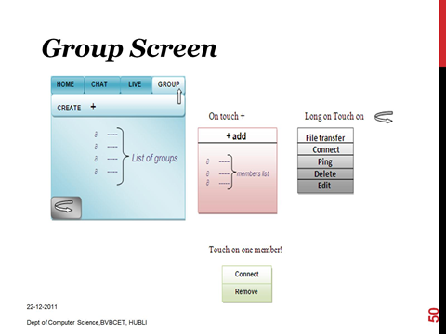

C DEPLOYMENT DIAGRAM

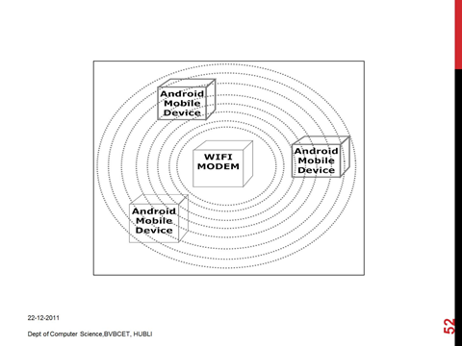

D DESIGN DECISIONS

* We adopted iterative model which facilitates us to develop prototypes in every iteration and get user feedback, which is necessary since we don’t have similar existing system.
* Language used to develop our application is java in order to use object oriented methodologies.
* Android SDK is used to design front end.
* Software used for our project is open source.

**5. CONCLUSION**

This paper has illustrated the implementation of a simple and efficient framework using standard multicasting facilities by building P2P applications demonstrating spontaneous group creation and content sharing within structured environments. Thus it has successfully represented the basic knowledge required to develop point to point communication framework for android platform.

**6 REFERENCES**

[i] Robosoft technologies pvt. Ltd